Andrew Fagundes
Department of Information Technology, Western Governors University
D209 Data Mining: Task 1
Professor Eric Straw
November 12th, 2024

Table of Contents
Part I: Research Question and Variables 4
A1: Research Question (k-nearest neighbor – KNN) 4
A2: Goal of the Data Analysis 4
Part II: Method Justification 5
B1: Explanation of Classification Method (how does it analyze the data and include expected outcomes) 5
B2: Summary of One Assumption of the Chosen Classification Method 6
B3: Packages or Libraries Used in Python and How They Support the Analysis 7
Part III: Data Preparation 7
C1: One Data Preprocessing Goal Relevant to KNN 7
C2: Initial Data Set Variables for Analysis and Classify Each Variable as Numeric or Categorical 9
C3: Explain Each Step to Prepare Data for Analysis – Identify Code for Each Step 9
C4: Provide Copy of Cleaned Data Set (this is in assessment submission) 16
Part IV: Model Analysis 17
D1: Split Data into Training and Test Data Sets and Provide File(s) (this is in assessment submission) 17
D2: Describe Analysis Technique to Analyze Data – Include screenshots of intermediate calculations 17
D3: Provide code used to perform classification analysis from part D2 19
Part V: Data Summary and Implications 21
E1: Explain Accuracy and Area Under the Curve (AUC) of Classification Model 21
E2: Discuss Results and Implications of Classification Analysis 24
E3: Discuss one limitation of your data analysis 25
E4: Recommend a course of action for the real-world organization situation from part A1 based on your results and implications discussed in part E2 25
References (No third-party code references used) 27
Table of Figures 29

Part I: Research Question and Variables

A1: Research Question (k-nearest neighbor – KNN)
For the medical data set, the research question is the following: “Can we classify whether a patient is hypertensive or not based on their characteristics?” This question can help a hospital determine what factors can estimate a patient’s high blood pressure. This question was also chosen to follow up with the research I did in D208 when using the logistic regression analysis. In that assessment, being overweight increased the likelihood that a patient would have high blood pressure. Since k-nearest neighbors requires the response variable to be categorical, this question was posed because “HighBlood”, the variable that indicates high blood pressure, is categorical.

A2: Goal of the Data Analysis
The goal of this KNN analysis is to test which variables are most closely related to patients having high blood pressure (“HighBlood”). KNN will be used to help classify a patient’s hypertension status based on patient-specific variables contained in the dataset. By determining what factors influence whether a patient is hypertensive or not, it could help the hospital prevent readmission due to this issue.

Part II: Method Justification

B1: Explanation of Classification Method (how does it analyze the data and include expected outcomes)
The KNN algorithm was chosen for several reasons. First, the KNN algorithm is simple to implement – given the dataset’s overall shape, it is easily and readily implemented and used. KNN is used because we are trying to solve a classification problem since the discrete value is the output. Moreover, the KNN algorithm only requires the k-value (neighbor proximity) to classify the label. KNN works by finding the distances between a query and all the examples in the data, selecting the specified number examples (K) closest to the query, then votes for the most frequent label (in the case of classification) or averages the labels (in the case of regression) (Harrison 2018). The algorithm checks the closest data points (neighbors) to help it in determining the target variables (HighBlood). Comparing new data points to its neighbors, the model will classify the target variable as either HighBlood yes or no. "KNN is one of the simpler prediction/classification techniques: there is no model to be fit (as in regression). This doesn't mean that using KNN is an automatic procedure. The prediction results depend on how the features are scaled, how similarity is measured, and how big K is set. Also, all predictors must be in numeric form." (Bruce, Bruce, & Gedeck, 2020). This method seems to be useful when working with the hospital data and questions as it allows new data points to be introduced and get classified to its proper section based on the surrounding data it lands by. This seems flexible and a great way to classify out data appropriately. The biggest advantages of KNN include:
- Quickest Calculation Time (Tavva, 2020)
- Simple Algorithms (Tavva, 2020)
- High Accuracy (Tavva, 2020)
- Versatile – best use for Regression and Classification. (Tavva, 2020)
- Doesn’t make any assumptions about data. (Tavva, 2020)
One expected outcome is to create an algorithm with a model accuracy of at least 95% without over or underfitting the model (Elleh 2024). Another expected outcome is to classify test data according to their closest neighbors (Elleh 2024; Harrison, 2019). The optimal K value usually found is the square root of N, where N is the total number of samples (Band 2020). Per industry standard, the k-value is the square root of the training instances (towarddatascience.com/machine-learning-basic-with-the-k-nearest-neighbors-algorithm-6a6e71d01761). The distance metric is the effective hyper-parameter through which we measure the distance between data feature values and new test inputs. The Euclidean distance is most common for KNN. Euclidean distance is based on Pythagoras’ theorem, which calculates the distance between two points p1 and p2.

B2: Summary of One Assumption of the Chosen Classification Method
One of the main assumptions of the KNN algorithm is that is work on the premise of proximity, that is that it is assumed those datapoints that are close to each other are similar. That is why when choosing the k-value for the algorithm, you are specifying how many close neighbors to choose (Harrison, 2018; Elleh 2024). This means that distance defines the classification of labels. If a data point is far away from another group, it’s dissimilar to those data points. The algorithm classifies new data points based on how the neighbors are classified (Medium, 2019).

B3: Packages or Libraries Used in Python and How They Support the Analysis
The libraries used in the analysis were the following: Pandas was used as the main data manipulation tool, Seaborn and Matplotlib were used to visualize the data, Numpy was used as numerical computation tool, and SKLearn was used to pre-process the data for the algorithm. SciPy was briefly used to create the z-scores required for eliminating outliers. KNeighborsClassifier was used to perform the KNN test. Train_test_split is used to split the cleaned data into training and testing data sets. GridSearchCV and SelectKBest are used for determining the best ‘k’ values and features to use in the model. ConfusionMatrix is used to print the confusion matrix of true and false positives and negatives. Roc_auc_score is used for creating the area under the curve score (AUC). Roc_curve is used for plotting the ROC curve. Classification_report is used for the summary of metrics such as accuracy, recall, specificity.

Part III: Data Preparation

C1: One Data Preprocessing Goal Relevant to KNN
One important step was to re-express the categorical explanatory variables. The data transformation that was required was limited to the re-expression of categorical variables to numerical variables. The reason the categorical variables are re-expressed is because most statistical methods and machine learning algorithms mining work exclusively with numeric data. This means that categorical data must be encoded to numbers to perform statistical modeling. For binary categorical columns, “Yes” will change to 1 and “No” to 0. For categorical variables with more than 2 levels or categories, you can use one-hot or dummy encoding. You do not need to drop a category. Rather you can combine, group, or cluster the levels or categories and then use binary encoding. Multicollinearity is not a concern of KNN. For instance: “drop_first=True” is inaccurate in Python. (Brownlee 2020, machinelearningmastery.com/one-hot-encoding-for-categorical-data/). (Saxena 2024, analyticsvidhya.com/blog/2020/08/types-of-categorical-data-encoding/). KNN methods uses distances to determine predictions, it is important that the predictor variables be standardized to avoid bias toward predictors that are on larger scales (Kuhn & Johnson, 2018, p. 352). The scikit-learn StandardScaler or MinMaxScaler method in Python helps for this. Categorical data, sometimes called qualitative data, are data whose values describe some characteristic or category. There are two types of categorical data, namely: ordinal, which is in an inherent order, and nominal, which are names only that are in no inherent order. One approach is to find and replace the dictionary created for cleaning up specific columns (Ex. Name of dataframe = dataframe.replace(name of dictionary)). Another approach is to encode categorical values is to use a technique called label encoding (https://pbpython.com/categorical-encoding.html). Label encoding is simply converting each value in a column to a number (https://pbpython.com/categorical-encoding.html). Some binary variables can be arranged as ordinal categorical variables such as Yes/No or True/False. A method to use for this is Ordinal Encoder Technique, which is done on Python through the OrdinalEncoder.fit_transform function (Straw 2024). For nominal data, one-hot encoding is the most widespread approach, and it works very well unless your categorical variable takes on many values. For one hot encoding, this has the benefit of not weighting a value improperly but does have the downside of adding more columns to the data set. For this step, the Pandas functionality, .map() was used for the binary nominal variables such as HighBlood, Stroke, Overweight, Arthritis, Diabetes, Hyperlipidemia, BackPain, Anxiety, Allergic_rhinitis, Reflux_esophagitis, and Asthma. The .map() function maps “Yes/No” to 1 and 0. For the nominal columns with multiple categories such as Gender, Area, Initial_admin, Marital, and Services, .get_dummies is used for one-hot encoding. Drop_first in the function is defined as “False” since it is advisable to retain the dummies (Bruce 2020). The OrdinalEncoder functionality from SKLearn was used for the only ordinal variable used in the model, Complication_risk.

C2: Initial Data Set Variables for Analysis and Classify Each Variable as Numeric or Categorical
Based on SelectKBest, the predictor variables with significant p-values (p < 0.05) were Overweight and Marital_Married. These variables are categorical. The response variable is HighBlood and is also categorical. SelectKBest is used to select the correct variables and eliminate those that do not help much with the prediction, thus improving a predictive model’s efficiency and effectiveness (Elleh 2024).

C3: Explain Each Step to Prepare Data for Analysis – Identify Code for Each Step
To being the assessment, we must import the proper libraries and packages to use for coding in Python. Then, we must load the clean medical dataset. This is done through pd.read_csv(‘medical_clean.csv”, index_col=0). 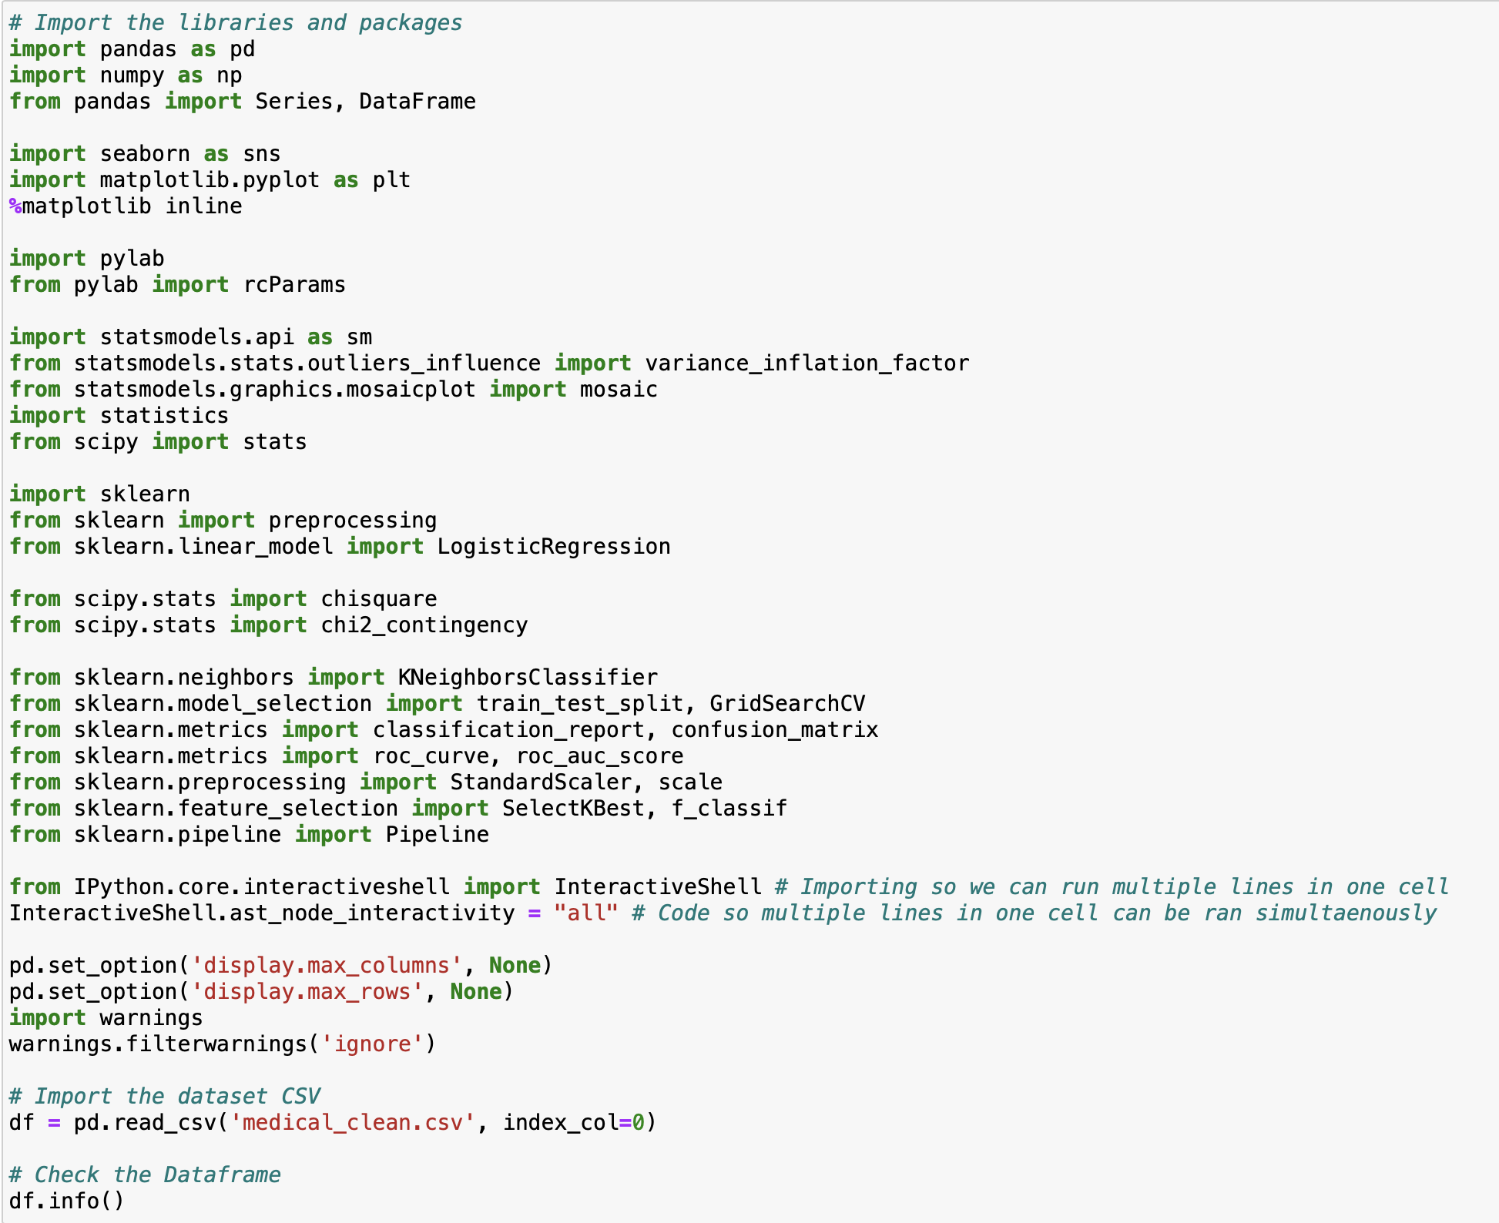
Figure 1: Importing Libraries and Loading the Data
Before beginning the KNN, it is crucial that we have cleaned and prepared the data for analysis. To do so, we will detect and treat duplicates, missing values, and outliers, as well as make necessary changes as appropriate such as re-expression of categorical variables into numerical variables and ensuring that the columns of the data frame are stored as the correct data type. First, we rename the columns to give proper naming to predictors. 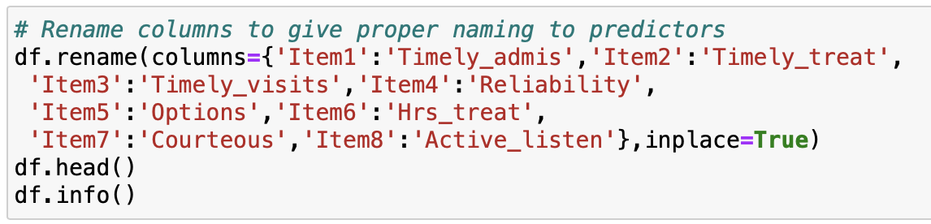
Figure 2: Renaming the Columns
To detect missing values, we will use df.isna().any() and df.isnull().sum(). If there are none, then the output should be False and 0. To detect duplicates, we will use df.duplicated().value_counts() to determine if any duplicates exist in the data frame. Next, we will find the count of unique values in each column with df.nunique() followed by using df[‘variableofinterest’].value_counts to find unique values for the independent and dependent variables (https://datascienceparichay.com/article/pandas-count-of-unique-values-in-each-column/, Piyush Raj 2024). Df.nunique() can also be used to determine the levels of cardinality of each variable. To detect outliers, we will use boxplots and z-scores to determine the outliers. Before detecting the z-scores, we scale the continuous data, so they all have the same range and are standardized. To do this, we import MinMaxScaler from sklearn.preprocessing. Then, we define scaler = MinMaxScaler(). Then, we scale the min and max of the continuous variables with .fit(). Finally, we create a new data frame with the transformed scaled data with scaler.fit_transform(). To detect z-scores, we use df[‘variableofinterest’]=stats.zscore(df[‘variableofinterest’]). The code for boxplots is the following: boxplot=sns.boxplot(df_scaled). Once the z-scores are recorded, the z_scores that are greater than 3 or less than -3 are removed from the data frame. Demographic data and irrelevant variables with more than three levels of cardinality will be removed since they are not relevant to the research question. This is done with the following code: df = df.drop(['Customer_id','Interaction', 'UID', 'City', 'State', 'County', 'Zip', 'Lat', 'Lng', 'Population', 'TimeZone', 'Job', 'Children','ReAdmis', 'Full_meals_eaten','vitD_supp', 'Soft_drink', 'Additional_charges', 'Timely_admis', 'Timely_treat', 'Timely_visits', 'Reliability', 'Options', 'Hrs_treat', 'Courteous', 'Active_listen'], axis=1, inplace=True). If any duplicate data entries, rows, or columns are found, they will be removed.
To use an efficient model for the KNN analysis, features must be analyzed and reduced based on p-values. To determine this, SelectKBest is used in Python. Feature selection is the process of selecting those features which contribute most to your prediction variable or output of your interest. We will use a p-value less than 0.05 as the threshold for selecting the variables. SelectKBest scores the features using a function with f_classif parameter. You can supply K=”all features” to show all features. This helps in selecting features having a significant p-value and building an improvised model. SelectKBest will select the K most explicative features out of the original set, so K should be a value greater than 0 and lower or equal to the total number of features.
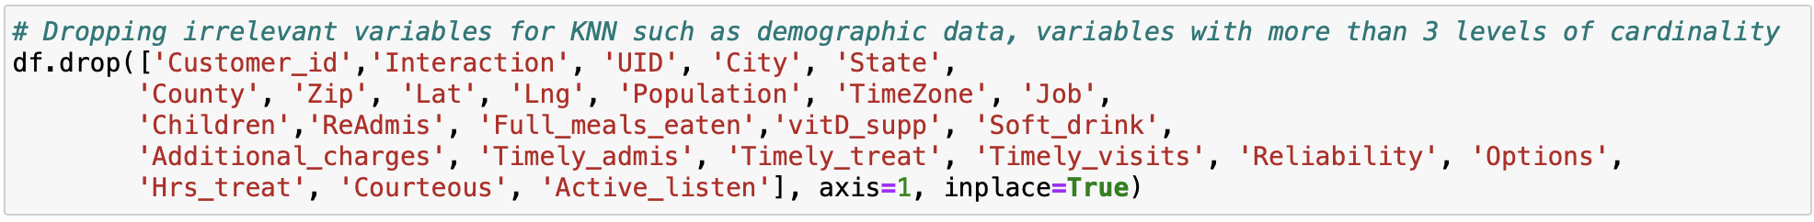
Figure 3: Dropping Demographic Data and Irrelevant Variables
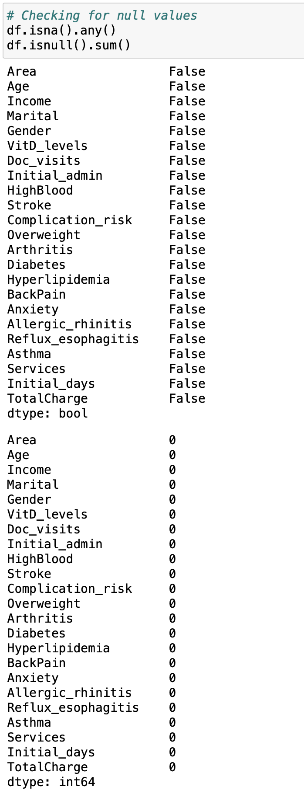
Figure 4: Checking for Null Values
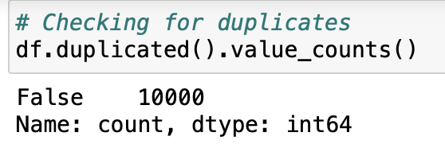
Figure 5: Checking for Duplicates
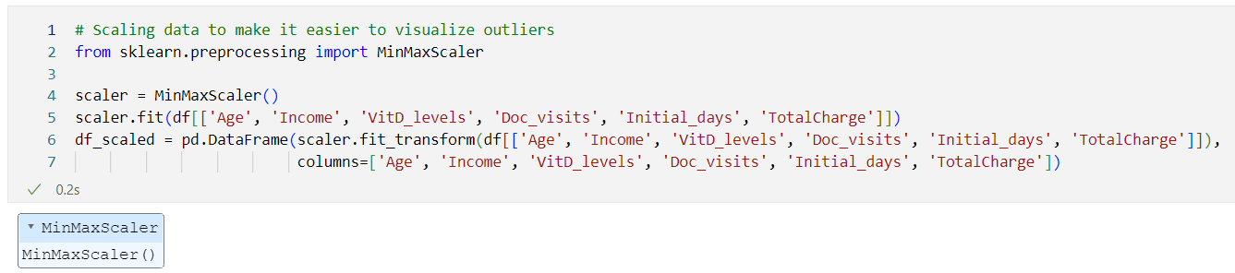
Figure 6: Scaling Continuous Data with MinMaxScaler
Using this dataframe and using Seaborn, boxplots were created to visualize the variables and determine which had outliers – in this case, income and VitD_levels both had outliers as shown below.
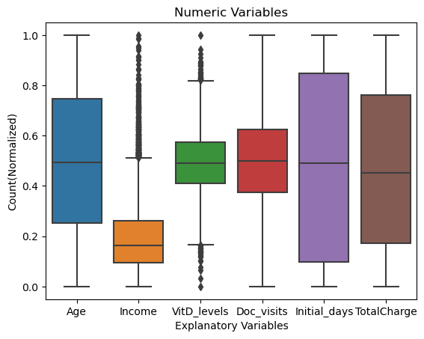
Figure 7: Boxplots for Outlier Detection
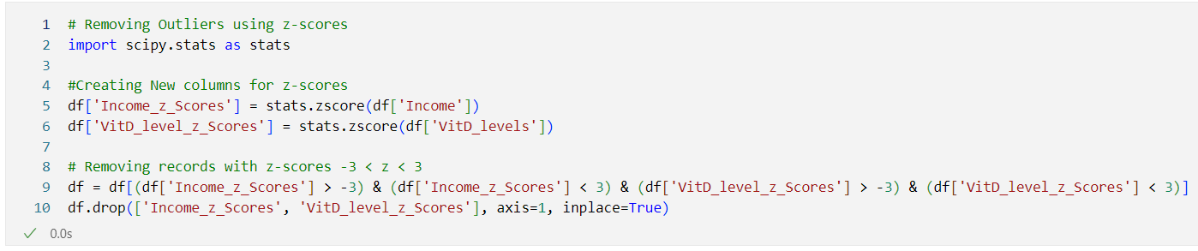
Figure 8: Z-Score Calculation for Outliers
The final data pre-processing step is re-expressing categorical variables. To convert the binary categorical columns, we used .map({‘Yes’: 1, ‘No’: 0}) to map ‘Yes/No’ to 1 and 0.
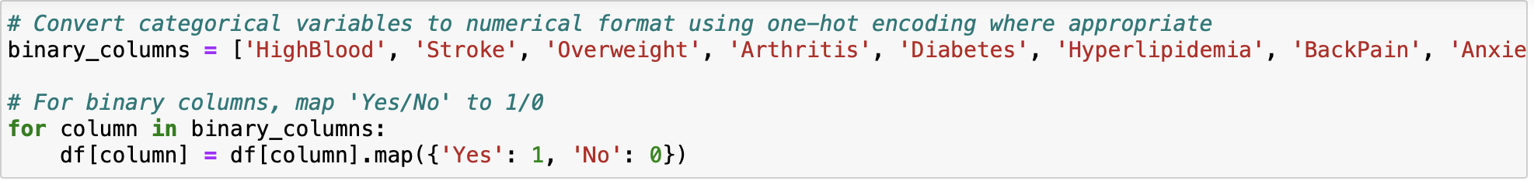
Figure 9: Mapping the Binary Categoricals
The .get_dummies() functionality from Pandas was used to convert the nominal variables with multiple categories such as Area, Marital, Gender, Initial_admin, Services. Drop_first is equal to false because the dummies should be kept in the KNN analysis.
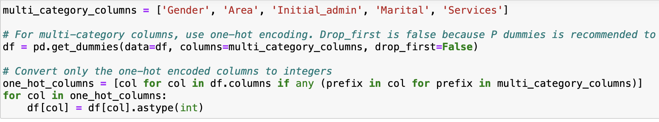
Figure 10: Get_dummies to Re-express Categorical Variables
The only ordinal variable was Complication_risk and for this OrdinalEncoder from SKLearn was used – Low, Medium and High were converted to 0, 1, 2 respectively.
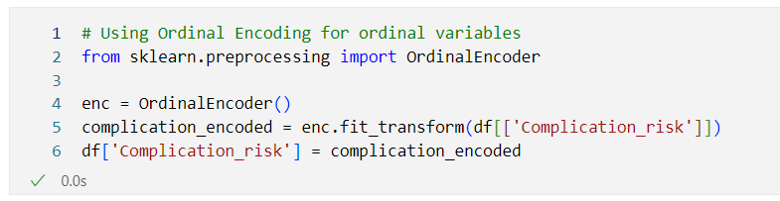
Figure 11: Ordinal Encoding for Complication_risk
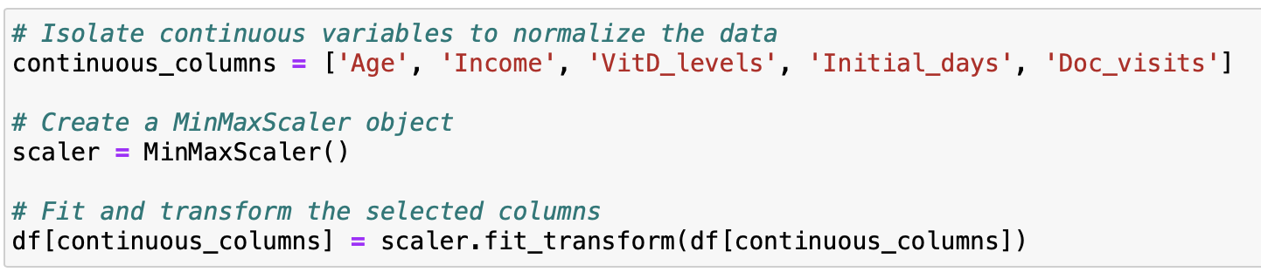
Figure 12: MinMaxScaler() for Continuous Variables after Encoding
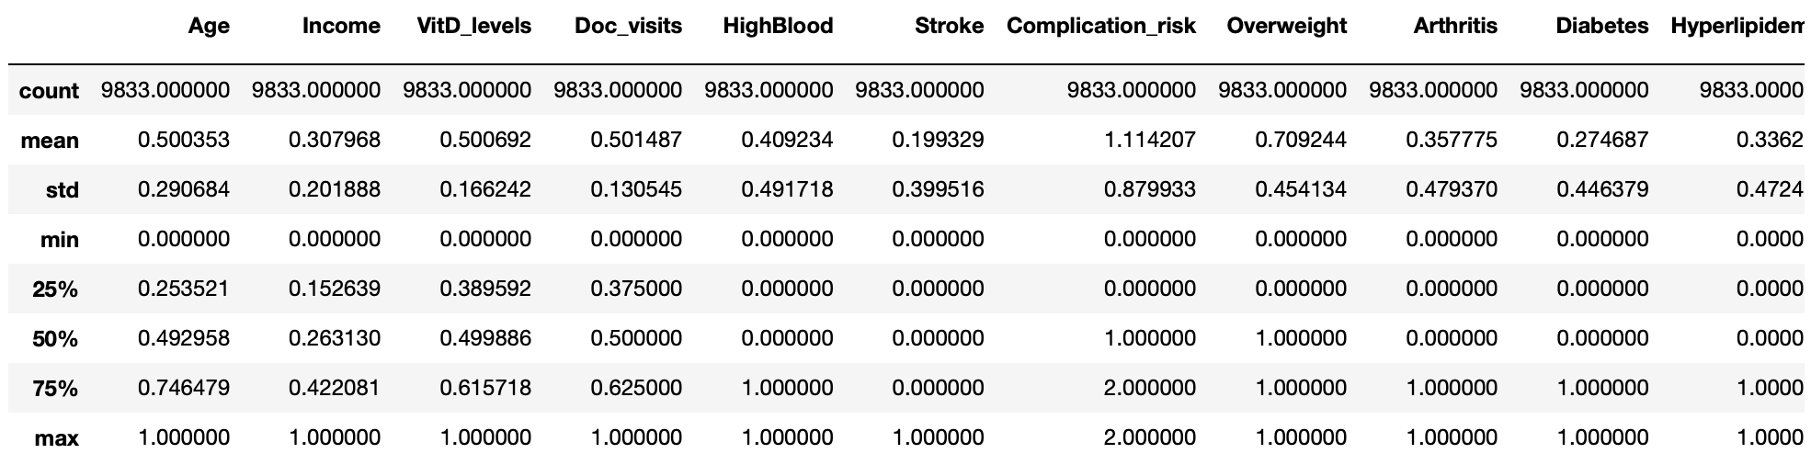
Figure 13: Summary Stats of Cleaned Data Frame
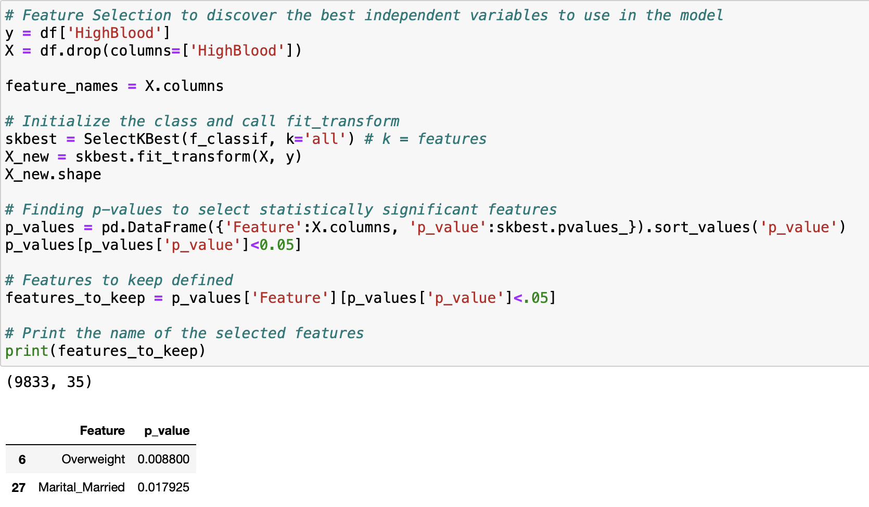
Figure 14: Feature Selection with SelectKBest
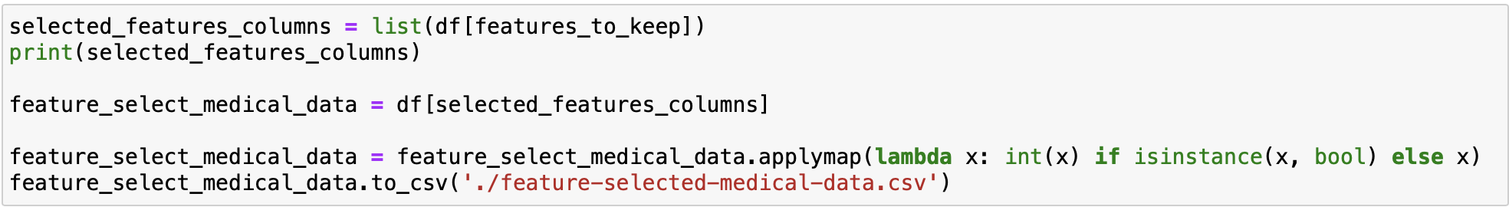
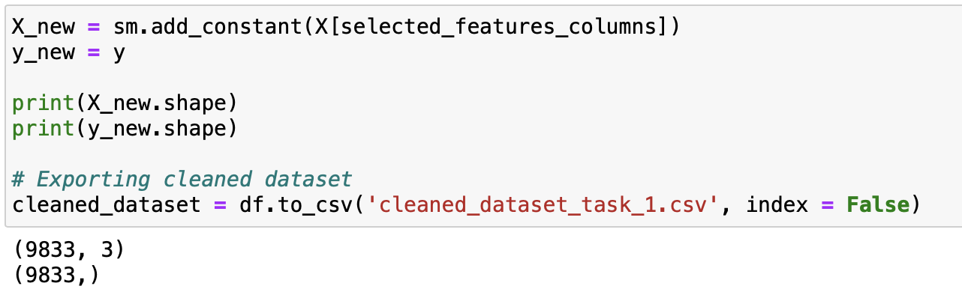
Figure 15: Cleaned Dataset Exported with New X and Y variables for Splitting the Data

C4: Provide Copy of Cleaned Data Set (this is in assessment submission)

Part IV: Model Analysis

D1: Split Data into Training and Test Data Sets and Provide File(s) (this is in assessment submission)

D2: Describe Analysis Technique to Analyze Data – Include screenshots of intermediate calculations
Before running the algorithm, the dataset was first split into a training and testing subset. Getting training and test data for features and the dependent variable requires using train_test_split function. This was performed using SKLearn’s model_selection function. A test size of 20% was used. Moreover, the option stratify was used to not have any one variable overpower the others with stratify = y. The data was passed to X_test, X_train, y_test and y_train respectively. The model is trained on the training data set and evaluated on the testing data set. This approach is called hold-out validation (Bruce 2020). Splitting the train and test data into subsets help improve accuracy.
The optimal K value usually found is the square root of N, where N is the total number of samples. Per industry standards, the k-value is the square root of the training instances. To determine this, .shape was used on the y and x variables to determine the total number of observations in the data set. The total number of observations was 9833. Then, np.sqrt() was used on 9833 to determine the square root. The square root was 99.16.
Once we have the square root, then we use the KNeighborsClassifier and GridSearchCV functions to determine the optimal number of neighbors needed to answer the research question. These functions will allow us to optimize for the best k value available. We can use the function GridSearchCV from scikit-learn that performs a grid search over a specified hyperparameter space to find the optimal combination of hyperparameters for a given machine learning model. First, the parameter grid, param_grid, is defined for number of neighbors along with the number of observations to use in np.arange. Then, we define KNN as the KNeighborsClassifier() function. Next, we define knn_cv as the GridSearchCV function with the variables of knn, param_grid, and cv=5 being used. Finally, we fit the GridSearch onto X-train and y-train along with .best_params_ to determine the optimal number of neighbors to use. The optimal k number of neighbors provided by this function is 74.
We used the best_score method to provide the best model accuracy score. This turned out to be 0.57. Then, the KNN classifier is fit to the training data with the optimal k value of 74. We then obtained the optimal value for n_neighbors, and the accuracy score on the training data set. The basic idea of k-NN is to predict the label of any data point by looking at the 'k' closest labeled data point based off the closest labeled data points and getting them to vote on what the unlabeled point should have. The new data point is then assigned the label based on the majority of ‘k' closest points. k-NN uses distance, and the standard Euclidean distance is the most common choice.
We will visualize our results with Receiver Operating Characteristic (ROC) Curve along with the confusion matrix. We will also print out the accuracies of the training and testing models. The ROC curve is the visual relationship between the true positive rate (TPR) and * false positive rate (FPR)* for various thresholds (Elleh 2024). After the ROC Curve is created, we can find the Area Under the Curve (AUC) to get a score of how it will work with the classification model. AUC is simply the total area under the ROC curve. The larger the value of AUC, the more effective the classifier. An AUC of 1 indicates a perfect classifier: If gets all the 1s correctly classified, and it doesn't misclassify any 0s as 1s (Bruce 2020). An area of 0.5 represents a model as good as random (Elleh 2024). Tools being used for ROC and AUC are confusion_matrix, roc_curve, roc_auc_score, and classification_report. The accuracy score describes the correct classifications over total samples (Elleh 2024). The confusion matrix illustrates the true and false positives and negatives (Bruce 2020).
Figure 16: Splitting Data into Train and Test Sets
Figure 17: Square Root of N Observations in Data

D3: Provide code used to perform classification analysis from part D2
The analysis technique used was k-Nearest Neighbor. The model was trained on the X_train and y_train datasets.
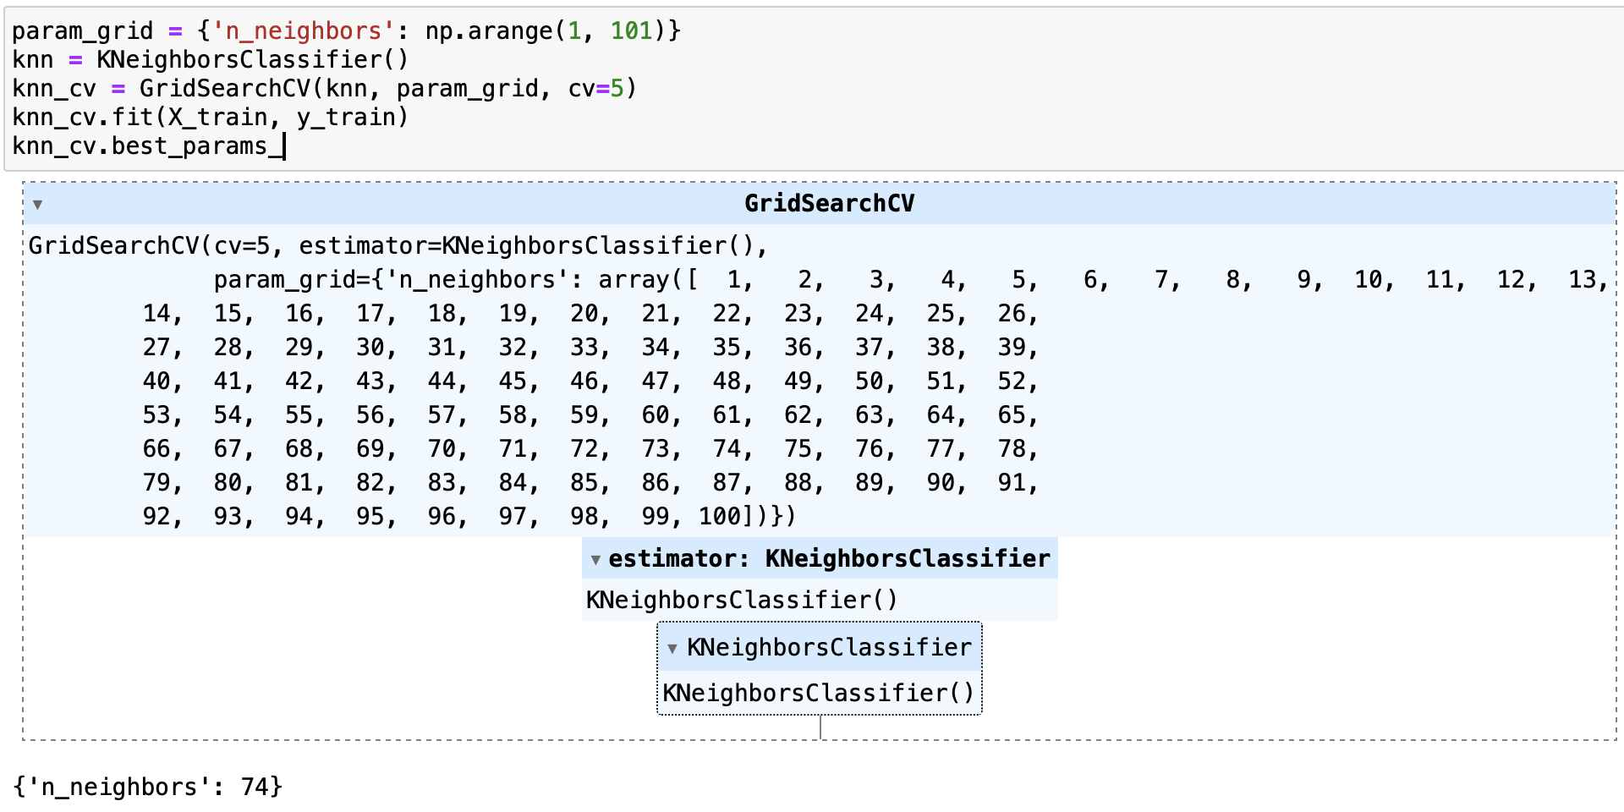
Figure 18: k-Nearest Neighbors: Created KNN Classifier. Used GridSearchCV to optimize for best k value
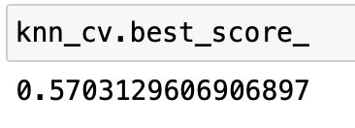
Figure 19: Best Accuracy of the KNN Model
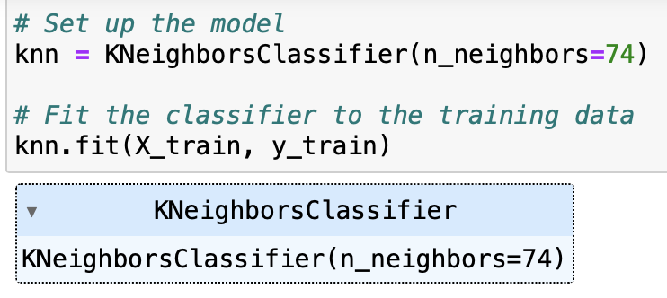
Figure 20: KNN Classifier Fit on Training Data with Optimal K Value

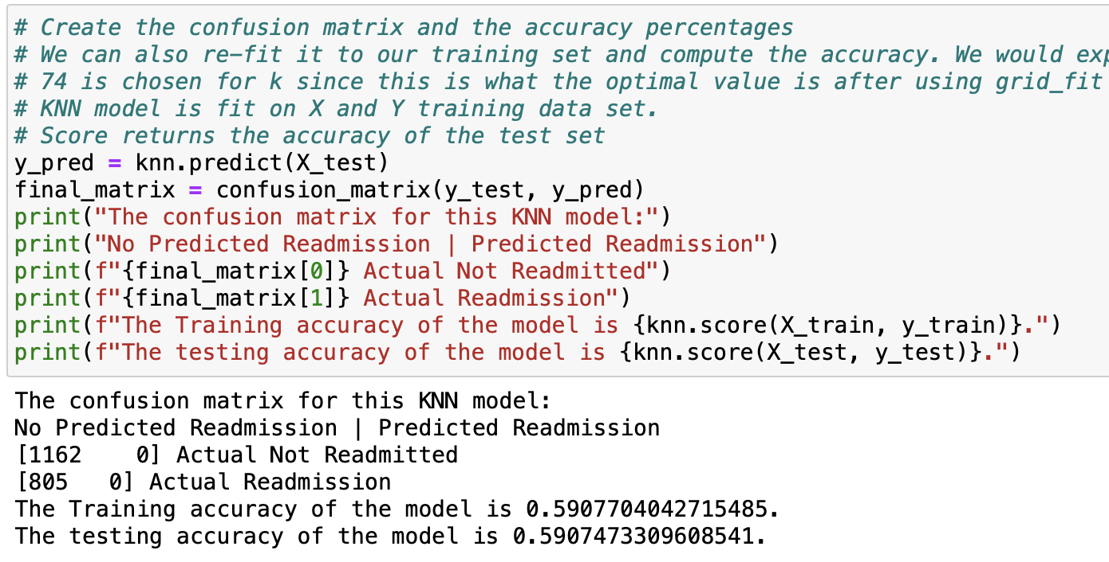
Figure 21: Confusion Matrix and Accuracies

Part V: Data Summary and Implications

E1: Explain Accuracy and Area Under the Curve (AUC) of Classification Model
Using the metrics functionality from SKLearn, we can determine how well our model performed. Specifically, the .score function returned values for the training and testing accuracies. The training accuracy of the model was 0.59077. The testing accuracy of the model was 0.59074. These accuracies represent that the models were accurate slightly more than half of the time in determining whether a patient was hypertensive (HighBlood = Yes) or not. Classification accuracy is the number of correct predictions made as a ratio of all the predictions (Brownlee, 2018). The confusion matrix illustrated 1162 true positives and 805 false positives. The AUC score was 0.516. The AUC represents a model’s ability to discriminate between positive and negative classes (Elleh 2024). An area of 1.0 represents a model that made all predictions perfectly (Elleh 2024). An area of 0.5 represents a model as good as random (Elleh 2024). There is technically no good or bad score, and the scores do vary by the field that the model is being used for. For example, a good AUC for financial modeling might differ from that used in healthcare and is also dependent on the quality of the data being used. A general rule of thumb prescribed to AUC is that a score below 0.7 would be considered poor (Hosmer, JE, Lemeshow, & Sturdivant, 2013). The precision score for 0 was 0.59. This represents the number of true positives divided by the number of true and false positives (Elleh 2024). The recall score for 0 was 1.00. This represents the number of true positives divided by the number of true positives plus the number of false negatives (Elleh 2024). The f1-score for 0 was 0.74. This represents the average of precision and recall scores (Elleh 2024).
Accuracy is the percent or proportion of cases classified correctly (Bruce 2020). Accuracy is equal to the sum of true positives plus the sum of true negatives divided by the sample size (Bruce 2020). A confusion matrix is used to display the record counts by their predicted and actual classification status (Bruce 2020). Sensitivity describes the percent or proportion of all 1s that are correctly classified as 1s, also known as the strength of the model to predict a positive outcome (Bruce 2020). Specificity describes the percent or proportion of all 0s that are correctly classified as 0s, also known as a model’s ability, to predict a negative outcome (Bruce 2020). Precision is the percent or proportion of predicted 1s that are actual 1s, also known as the accuracy of a predicted positive outcome (Bruce 2020). The ROC curve is a plot of sensitivity versus specificity (Bruce 2020). In most classification algorithms, each case is assigned an “estimated probability of being a 1” (Bruce 2020). The default decision point, or cutoff, is typically 0.50 or 50% (Bruce 2020). If the probability is above 0.5, the classification is “1”; otherwise, it is “0” (Bruce 2020). An alternative default cutoff is the prevalent probability of 1s in the data (Bruce 2020). In the confusion matrix, the predicted outcomes are columns, and the true outcomes are the rows (Bruce 2020). The diagonal elements of the matrix show the number of correct predictions, and the off-diagonal elements show the number of incorrect predictions (Bruce 2020). The diagonal boxes (upper left, lower right) show when the predictions correctly predict the response (True Positive, True Negative) (Bruce 2020).
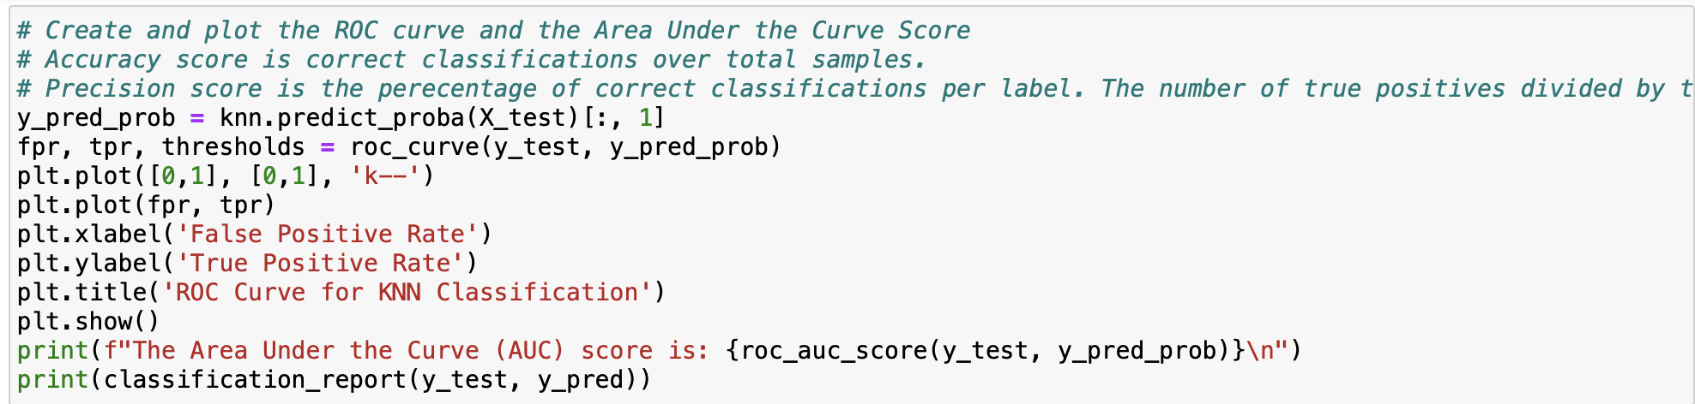
Figure 22: Code for ROC and AUC
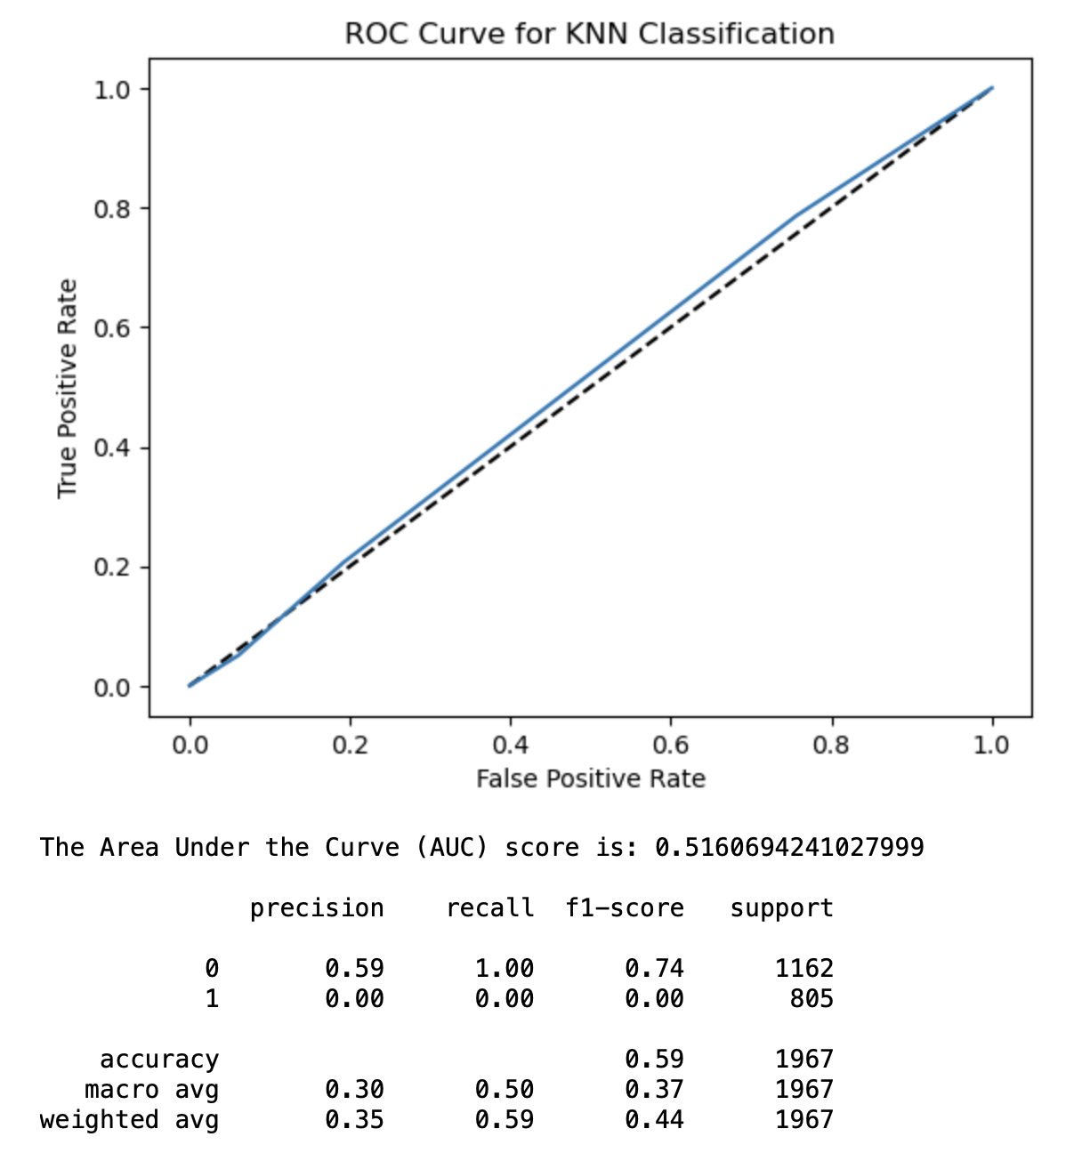
Figure 23: ROC Curve and Classification Report

E2: Discuss Results and Implications of Classification Analysis
The results of the model showed that it was no better at predicting whether the patient was hypertensive or not – the accuracy score and AUC verified this fact. The KNN (k-nearest neighbor) model had a poor AUC (Area Under the Curve) coming in at 51% (0.5160.) This model is not very accurate when it comes to classifying high blood pressure in hospital patients. One positive is that SelectKBest allowed us to find the most statistically significant features to add to the model based on p-values. The problem is that KNN analysis does not do a great job of classifying high blood pressure even with the hyperparameter tuning and optimization of p-values. More labeled data would be needed to train the model to determine if the model would improve at all.

E3: Discuss one limitation of your data analysis
There were some limitations during the analysis that could have impacted on the score. For one, the data itself is not real-world data. The data usually collected in healthcare institutions are more in-depth and contain more explanatory variables that can help the model. Secondly, the HighBlood class could have been imbalanced. For instance, out of 9,833 observations, 5,809 did not have high blood pressure while only 4,024 did. This might result in getting the less common class of high blood pressure wrongly classified. Finally, the k value might have been inappropriate which could have led to poor classifications. This means that trial and error would be needed to discover a better k value. If K is too low, we may be overfitting: including the noise in the data (Bruce 2020). Higher values of K provide smoothing that reduces the risk of overfitting in the training data (Bruce 2020). On the other hand, if K is too high, we may over smooth the data and miss out on KNN’s ability to capture the local structure in the data, one of its main advantages (Bruce 2020). The K that best balances between overfitting and over smoothing is typically determined by accuracy metrics and accuracy with holdout or validation data (Bruce 2020). There is no general rule about the best K – it depends greatly on the nature of the data (Bruce 2020). For highly structured data with little noise, smaller values of K work best (Bruce 2020). Typically, values of K fall in the range 1 to 20 (Bruce 2020). Often, an odd number is chosen to avoid ties (Bruce 2020).

E4: Recommend a course of action for the real-world organization situation from part A1 based on your results and implications discussed in part E2
Based on this analysis report and the model’s accuracy score, the hospital can’t use this k-NN model to predict patients who are hypertensive. The model could be further improved by performing hyperparameter tuning on additional parameters by using more labeled data to train the model. Based on exploratory data analysis and SelectKBest, patients who were Overweight and Married were more likely to be hypertensive. To achieve better results, a bigger dataset comprising of more explanatory variables could help the results – more data means a bigger training set could be used so the model can have better predictive power. Moreover, there are other clinical parameters that can help in predicting hypertensive status – kidney disease (or lack thereof), activity level and other metabolic parameters can provide better real-world value rather than some of the variables shown in the dataset. Thirdly, varying stages of hypertensive status exist; the model cannot discriminate which stage a patient can potentially be in and is something that would have to be verified by a human clinician (American Heart Association, 2023). Given the statistical significance of the Overweight and Married variables, it is possible that the hospital could help patients with their diets by recommending them to personal trainers, dieticians, or providing insights on how to improve their nutritional habits. For people who are married, providing recommendations to marriage counselors or therapists could help improve their situation.

References (No third-party code references used)
Dr. Festus Elleh. (November 2024). D209 Webinars with Dr. Festus Elleh
Jo Hardin, Jason Vestuto, Nele Verbiest, Maggie Matsui, Richie Cotton, Maarten Van den Broeck. D209 – Data Mining. https://app.datacamp.com/learn/custom-tracks/custom-d209-data-mining.
Stojilikovic, Mirko (July 15th, 2024). Split Your Dataset with scikit-learn’s train_test_split(). https://realpython.com/train-test-split-python-data/.
Bruce, Peter, et al. (April 10, 2020). Practical Statistics for Data Scientists: 50+ Essential Concepts Using R and Python. O’Reilly Media; 2nd edition
Raj, Piyush. Pandas – Count of Unique Values in Each Column. https://datascienceparichay.com/article/pandas-count-of-unique-values-in-each-column/.
Moffitt, Chris. (February 6th, 2017). Guide to Encoding Categorical Values in Python. https://pbpython.com/categorical-encoding.html.
American Heart Association. (2024, May 17). Understanding Blood Pressure Readings. Retrieved from High Blood Pressure: https://www.heart.org/en/health-topics/high-blood-pressure/understanding-blood-pressure-readings
Harrison, O. (2018, September 10). Machine Learning Basics with the K-Nearest Neighbors Algorithm. Retrieved November 2024, from Towards Data Science: https://towardsdatascience.com/machine-learning-basics-with-the-k-nearest-neighbors-algorithm-6a6e71d01761
Hosmer, JE, D. E., Lemeshow, S., & Sturdivant, R. X. (2013). Model-Building Strategies and Methods for Logistic Regression. Wiley. Retrieved November 2024, from https://doi.org/10.1002/9781118548387.ch4
Vanderplas, J. (n.d.). Classification Models. Retrieved November 2024, from 1.6. Nearest Neighbors: https://scikit-learn.org/stable/modules/neighbors.html#classification
Zach. (2021, September 9). What is Considered a Good AUC Score? Retrieved November 12, 2024, from Statology: https://www.statology.org/what-is-a-good-auc-score/
Band, Amey. (2020, May 23). How to find the optimal value of K in KNN? Retrieved November 12, 2024, from Towards Data Science: https://towardsdatascience.com/how-to-find-the-optimal-value-of-k-in-knn-35d936e554eb.
Tavva, R. (2020, October 10). K Nearest Neighbour For Supervised Learning. Data Science Blog. https://data-science-blog.com/blog/2020/10/10/k-nearest-neighbour-for-supervised-learning/
Stack Overflow. (2018, Oct 20). Implementing roc curves for k-nn machine learning algorithm using python and scikit learn. https://stackoverflow.com/questions/52910061/implementing-roc-curves-for-k-nn-machine-learning-algorithm-using-python-and-sci
M. C., By, -, Marina Chatterjee https://www.mygreatlearning.com (2024, September 2nd). A Quick Introduction to KNN Algorithm. GreatLearning Blog: Free Resources what Matters to shape your Career! Retrieved November 11, 2024, from https://www.mygreatlearning.com/blog/knn-algorithm-introduction/.

Table of Figures
Figure 1: Importing Libraries and Loading the Data 10
Figure 2: Renaming the Columns 11
Figure 3: Dropping Demographic Data and Irrelevant Variables 12
Figure 4: Checking for Null Values 14
Figure 5: Checking for Duplicates 14
Figure 6: Scaling Continuous Data with MinMaxScaler 14
Figure 7: Boxplots for Outlier Detection 14
Figure 8: Z-Score Calculation for Outliers 15
Figure 11: Mapping the Binary Categoricals 15
Figure 12: Get_dummies to Re-express Categorical Variables 15
Figure 13: Ordinal Encoding for Complication_risk 15
Figure 14: MinMaxScaler() for Continuous Variables after Encoding 16
Figure 15: Summary Stats of Cleaned Data Frame 16
Figure 16: Feature Selection with SelectKBest 16
Figure 17: Cleaned Dataset Exported with New X and Y variables for Splitting the Data 17
Figure 18: Splitting Data into Train and Test Sets 19
Figure 19: Square Root of N Observations in Data 19
Figure 20: k-Nearest Neighbors: Created KNN Classifier. Used GridSearchCV to optimize for best k value 20
Figure 21: Best Accuracy of the KNN Model 20
Figure 22: KNN Classifier Fit on Training Data with Optimal K Value 20
Figure 23: Confusion Matrix and Accuracies 21
Figure 24: Code for ROC and AUC 23
Figure 25: ROC Curve and Classification Report 24

